
2024 annual report to the Community

Macclesfield Primary School

Macclesfield Primary School number: 239


Partnership: Heysen

Signature

Wendy Silvestri

  School principal:
 |  |  |  |  |  |  |  | 
  Date of endorsement:
  03/02/2025

Context Statement

Macclesfield Primary School caters for students from R-6. At the time of this report, the enrolment in 2024 is 76. Macclesfield Primary School is classified as Category 6 on the Department for Education Index of Educational Disadvantage. At the time of this report, the school population includes , 5% students with disabilities, 1% children/young people in care. Further information about the school is available on the school's website (including its context statement), as well as the My School website.

Data Source: Department for Education data holdings from Mid census captured in AUGUST 2024.

Governing Council Report

What an unexpected but extremely positive 2024. We are pleased to report a substantial increase in our student population.
Enrolment Growth Our enrolment numbers have risen from 51 to 76 students. This growth is a testament to the quality of education and the supportive environment we offer at Macclesfield Primary School. A noteworthy aspect of this increase is that many of the new students have transitioned from the private school system. This shift indicates a growing recognition of the value and benefits of public education at our school. The increase in enrolment is a positive development for Macclesfield Primary School. We are committed to leveraging this growth to enhance our educational offerings and continue providing an exceptional learning environment for all students while still maintaining our commitment to small class sizes, personalised learning and a strong community feel.
Facility Improvements We have also begun a cycle of improving our learning environments and have begun implementing
- Classroom Enhancements: Three classrooms have been newly painted and improved, creating a more vibrant and conducive learning environment for our students.
- Development of the Wellbeing Room: We have established a new wellbeing room, known as "The Retreat." This space is designed for students to access sensory breaks and self-regulation activities, supporting their ability to remain successful learners. We have made better utilisation of the teacher resource room previously known as “The Dungeon” and created an inviting space for students to access
- Decluttering: We looked at our resources ensuring that resources more accessible to staff and that resources were relevant, up to date and were supported by research. We also improved our admin area by streamlining our storage and printing areas. Improving the first impression we give as a school.
Sporting Initiatives We were excited that our school received 2 sporting grants, which has enabled us to introduce new sport opportunities for students to try
- Ultimate Frisbee and Basketball: The entire school participated in these new sports, fostering teamwork, physical fitness, and enthusiasm for physical education.
Annual Events and Activities In addition to these new developments, we continue to offer a range of enriching activities and events, including but not limited to:
- Festival of Music: Our students participated in this annual celebration of musical talent.
- Sports Day: A day filled with fun and competition, promoting physical fitness and school spirit.
- Top Block Nature Play: Encouraging creativity and exploration in our natural play spaces.
- Incursions and Excursions: Providing diverse learning experiences beyond the classroom.
- Swimming and Aquatics: Essential skills and fun in the water.
- Graduation: Celebrating the achievements of our graduating students.
- SAPSASA and Hot Shot Participation: Engaging in interschool sports competitions.

In 2025 we look forward to discussing and building on our successes.

Performance Summary

NAPLAN Proficiency

In 2023 the Australian Curriculum, Assessment and Reporting Authority (ACARA) - a Commonwealth Independent statutory authority - announced changes to NAPLAN performance reporting. The new approach replaces the previous numerical NAPLAN bands and the national minimum standard.

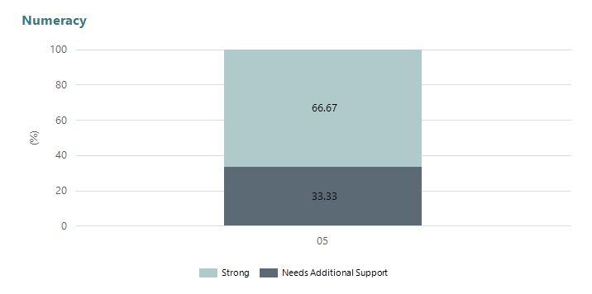
Year Level | 05
Strong | 4
Needs Additional Support | 2
Total | 6

Data Source: Department for Education Assessment Data Holdings, 2024. If there are less than 6 students who sat NAPLAN in a school, no information will be shown. If a year level has less than 6 students, that year level will not be shown in NAPLAN results.

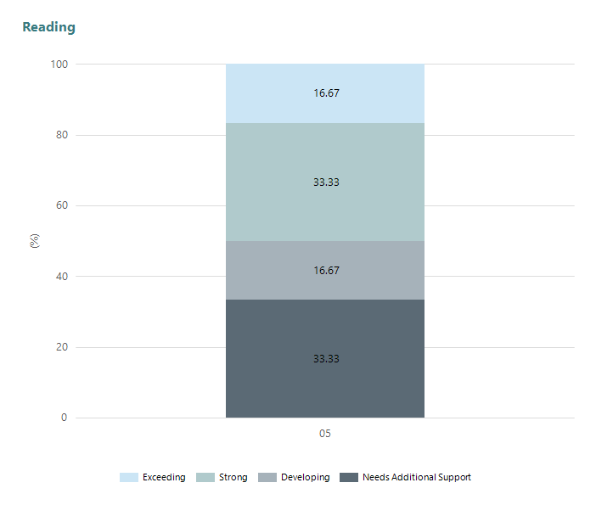
Year Level | 05
Exceeding | 1
Strong | 2
Developing | 1
Needs Additional Support | 2
Total | 6

Data Source: Department for Education Assessment Data Holdings, 2024. If there are less than 6 students who sat NAPLAN in a school, no information will be shown. If a year level has less than 6 students, that year level will not be shown in NAPLAN results.

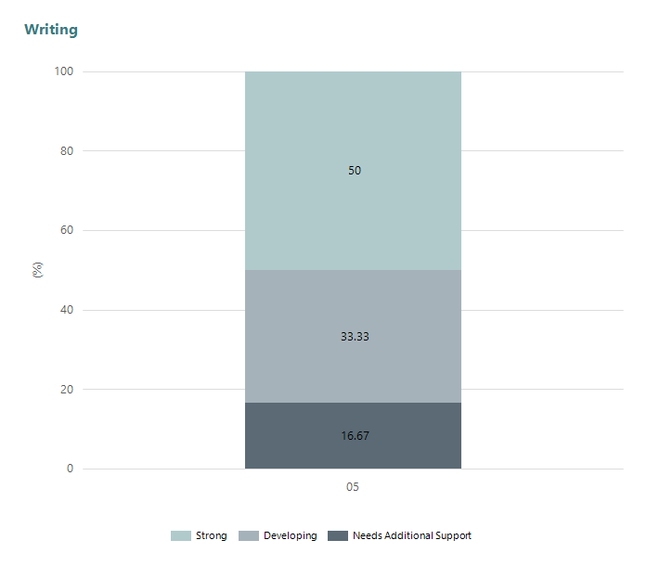
Year Level | 05
Strong | 3
Developing | 2
Needs Additional Support | 1
Total | 6

Data Source: Department for Education Assessment Data Holdings, 2024. If there are less than 6 students who sat NAPLAN in a school, no information will be shown. If a year level has less than 6 students, that year level will not be shown in NAPLAN results.

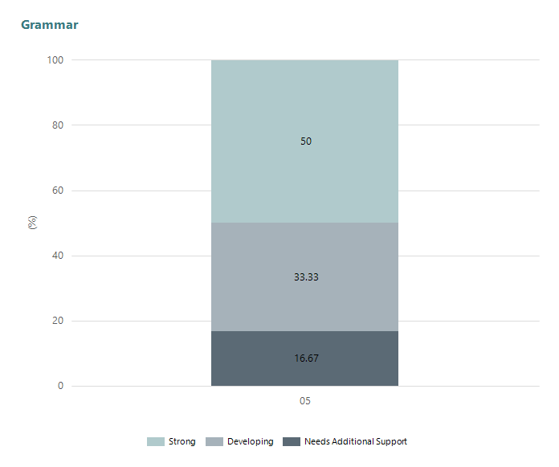
Year Level | 05
Strong | 3
Developing | 2
Needs Additional Support | 1
Total | 6

Data Source: Department for Education Assessment Data Holdings, 2024. If there are less than 6 students who sat NAPLAN in a school, no information will be shown. If a year level has less than 6 students, that year level will not be shown in NAPLAN results.

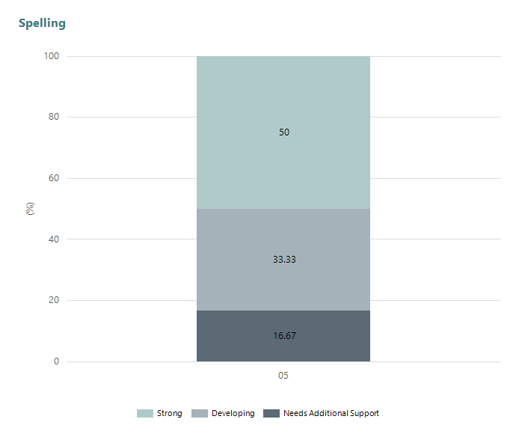
Year Level | 05
Strong | 3
Developing | 2
Needs Additional Support | 1
Total | 6

Data Source: Department for Education Assessment Data Holdings, 2024. If there are less than 6 students who sat NAPLAN in a school, no information will be shown. If a year level has less than 6 students, that year level will not be shown in NAPLAN results.

Page Breaker

School Attendance

Year Level | 2022 | 2023 | 2024
Reception | 91.6% | 90.4% | 94.8%
Year 01 | 91.2% | 92.0% | 84.0%
Year 02 | 90.0% | 76.1% | 92.2%
Year 03 | 91.6% | 91.3% | 90.2%
Year 04 | 92.0% | 95.8% | 91.9%
Year 05 | 74.3% | 85.9% | 95.3%
Year 06 | 95.5% | 77.7% | 89.2%
Total | 91.2% | 88.8% | 91.4%

Data Source: Department for Education Attendance Data, Semester 1 Report 2024. A blank cell indicates there we no students enrolled. 'Primary Other' includes students enrolled in specialised education options. 'Secondary Other' includes students who have already spent a year at Year 12 and elected to undertake further study at Year 12.

Attendance Comment

In South Australia, all children and young people must be in school from 6 years to 16 years old. They must attend a government or non-government school full time. From age 16 to 17 however, young people must attend school or an approved learning program (such as an apprenticeship, traineeship, accredited course or university). Schools and parents must encourage and support students to come to school every day. Parents and caregivers must make sure their child is enrolled in a school, and attends school all day and everyday it is open, unless a child is sick or has an approved exemption. Teachers and leaders actively follow up when a student misses school, including recording all absences and non-attendance. All schools in South Australia have local attendance procedures governed under the Education and Children's Services Regulations 2020.

School Parent Opinion Survey Results

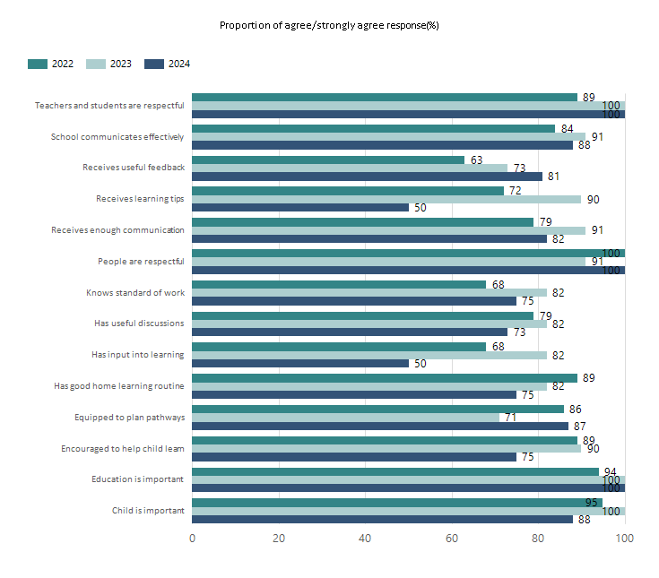
Data Source: 2024 Department for Education Parent Opinions Survey, Term 3 2024.

Page Breaker

Intended Destination

Leave Reason | Number | %
TA - LEFT SA FOR TAS | 1 | 50.0%
TG - TRANSFERRED TO SA GOVERNMENT SCHOOL | 1 | 50.0%

Data Source: Department for Education Destination Data Report, 2024. Data extract term 3 2024. Data shows recorded destinations for students that left the school in the previous year. Data is uploaded by schools in term 3 and may not reflect final or total figures at time of report creation.

Highest Qualifications held by the teaching workforce and workforce composition

All teachers at this school are qualified and registered with the SA Teachers Registration Board.

Qualification Level | Number of Qualifications
Bachelor's degrees or Diplomas | 5
Postgraduate Qualifications | 1

Data Source: Data extracted from Mandatory Workforce Information Collections as on the last pay date of June 2024. As self-reported by staff in the system.

Please note: Data includes staff who are Actively employed and on extended paid leave. Please note only the highest qualification of the Teaching staff is reported. Excludes any number of other certifications earned.

Workforce composition including indigenous staff

 | Teaching Staff |  | Non-Teaching Staff
 | Indigenous | Non-Indigenous | Indigenous | Non-Indigenous
Full-Time Equivalents | 0.0 | 5.6 | 0.0 | 1.9
Persons | 0.0 | 6.0 | 0.0 | 3.0

Data Source: Data extracted from Mandatory Workforce Information Collection as on the last pay date of June 2024.

Please note: Data includes staff who are actively employed and on extended paid leave. "Indigenous category" is self-reported by staff in the system.

Financial Statement

Funding Source | Amount
Grants: State | NIL
Grants: Commonwealth | $4,500.00
Parent Contributions | $20,551.41
Fund Raising | $9,109.34
Other | $4,099.70

Data Source: School supplied data.

